

**SOFE4790 Distributed Systems (Fall 2021 - Dr. H. Singh)**

**Lab#1 – Client / Server Communication**

**Honour code**: By submitting this lab report, I (name and banner ID# below) affirm this is my own work, and I have not asked any of my fellow students or others for their source code or solutions to complete this lab, and I have not offered my source code or solutions for this lab to any of my fellow students.

**Name**: Kaushik Ramani

**Banner ID#**: 100651855

Note: please adjust the number of tasks for each lab as needed.

**Task #1:** write the name of the task as in the lab document

1. **Briefly explain how you accomplished the task**

Checked if PC was connected to the internet via ethernet (for the ethernet portion of this task). Then, navigated to <https://www.speedtest.net/> to record my internet speed. Disconnected from ethernet to connect to the internet on WiFi, then proceeded to run the speedtest again.

1. **Results**

*Ethernet*

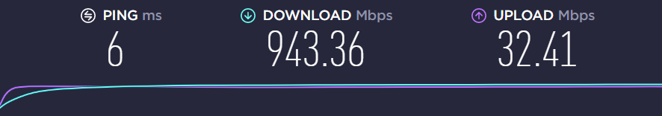

*WiFi 5GHz*

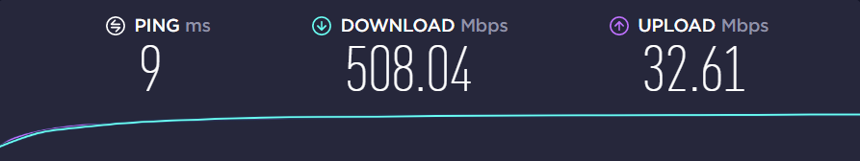

1. **Challenges and solutions** (if you did not face any challenges, just write so)
2. **Do your Internet speeds match your ISP subscription?**

The Internet plan I have subscribed to is supposed to provide **1Gbps download** and **30 Mbps upload.** After running the test, the results I got whilst connected to ethernet is very close to the advertised speeds. However, the results I got whilst connected to WiFi seems very slow compared to the advertised speeds.

1. **How does the wi-fi speed compare to the Ethernet speed? If you’re unable to test your Ethernet speed for any reason, then comment on the wi-fi speeds.**

The WiFi results seem to always be around half the ethernet speeds when testing. **Ethernet** speeds I recorded was very close (**943Mbps**) to the advertised speed of **1Gbps** download however, I repeatedly only got **500Mbps** on **WiFi**.

1. **How does the speed test work? Please do not copy the detailed answers from online resources, just provide one simple paragraph in your own words.**

Usually, internet speedtests make you connect to one of their many servers (usually one that has the best ping) that are hosted around the world. From there, to test ping, the client(your PC) sends a message to the server and waits for a response.

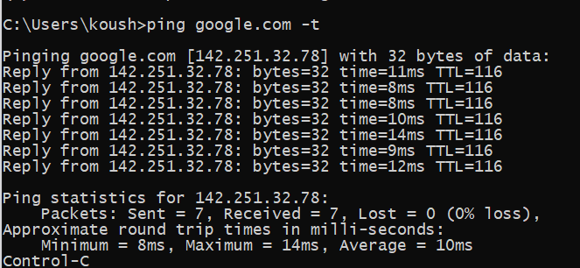 The total time it took between sending and receiving a message (the round-trip) is the result for the **Ping** portion of the test.

The **Download** portion of the test is basically the same except instead of one message or connections, multiple connections are made to the server and requests chunks of data. While the client is receiving the chunks, it will also calculate the real-time speed of the transfers. If the client determines it has more headroom, it will request the chunk size to be larger.

The **Upload** portion of the test is basically the **reverse** of the **Download** portion of the test.

1. **Briefly explain the concept and differences in: Network Bandwidth, Throughput, and Latency?**

**Network bandwidth** is the volume of data that can be set over a single connection. (Think 1 lane road compared to a 5 lane highway)

**Network Throughput** is the actual amount of data transferred between places. While network bandwidth tells you hou much data could theoretically be transferred from one source to another.

**Network Latency** is the measured time difference between sending a message to a server and receiving a response.



**Task #2:** write the name of the task as in the lab document

1. **Briefly explain how you accomplished the task**



Added lines to print Client IP and Port

1. **Results**



1. **Challenges and solutions**

Did not realize I had to compile the java file each time I made a modification, wasted a lot of time trying out other solutions before realizing this.

**Task #3:** write the name of the task as in the lab document

1. **Briefly explain how you accomplished the task**
2. **Results**
3. **Challenges and solutions**

**Task #4:** write the name of the task as in the lab document

1. **Briefly explain how you accomplished the task**
2. **Results**
3. **Challenges and solutions**